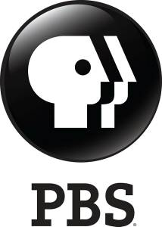

Presents

BILL NYE: SCIENCE GUY

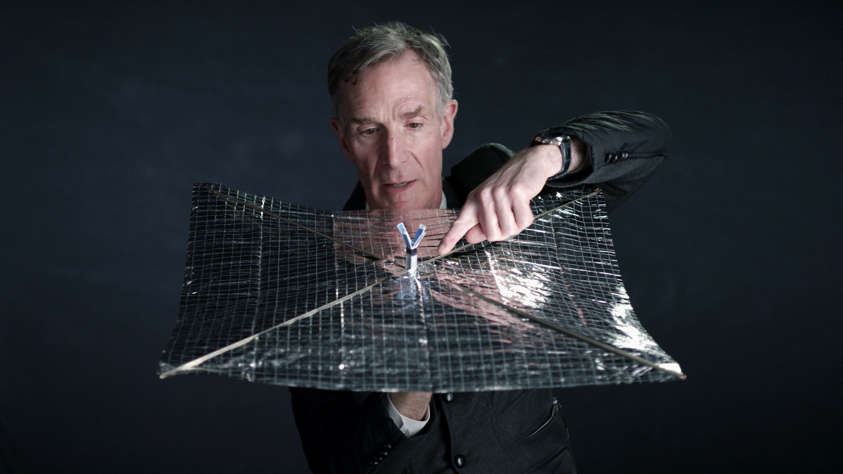

Directed by David Alvarado and Jason Sussberg

**Official Selection—Documentary Spotlight—SXSW Film Festival**
**Official Selection—HotDocs**
**Official Selection—Los Angeles Film Festival**
**Official Selection—AFI Docs**

Release Date: October 27 at Landmark Sunshine in NYC + November 10 at Landmark Nuart in LA
Running Time: 97 minutes
Languages: English

New York Publicity:  Obscured Pictures  RJ Millard / Katherine Matthews  rj@obscuredpictures.com  katherine@obscuredpictures.com  212.620.0727 | Los Angeles Publicity:  Prodigy Public Relations  Alex Klenert / Hanna Frankel  ak@prodigypublicrelations.com  hf@prodigypublicrelations.com  310.857.2020 | Distribution Contact:  PBS Distribution  Erin Owens  eeowens@pbs.org  917.940.1687

www.BillNyeFilm.com @billnyefilm
SYNOPSIS

Bill Nye is a man on a mission: to stop the spread of anti-scientific thinking across the world. The former star of the popular kids show "Bill Nye The Science Guy" is now the CEO of The Planetary Society, an organization founded by Bill's mentor Carl Sagan, where he's launching a solar propelled spacecraft into the cosmos and advocating for the importance of science, research, and discovery in public life. With intimate and exclusive access--as well as plenty of wonder and whimsy--this behind-the-scenes portrait of Nye follows him as he takes off his Science Guy lab coat and takes on those who deny climate change, evolution, and a science-based world view. The film features Bill Nye, Neil deGrasse Tyson, Ann Druyan, and many others.

DIRECTORS’ STATEMENT

We’re documentary filmmakers, but we’re also Bill Nye fans who spent our middle school years learning about the ecosystem and the color spectrum from his trusty VHS tapes. Bill’s passion and enthusiasm stayed with us, and when we got older, we started making films about science and technology. When we learned that Bill Nye was doing something new—working outside of the classroom to champion science and space exploration and helping lead the fight against climate change, we knew we had to make this documentary.

As filmmakers, we tell stories about interesting people in the worlds of science, health, information and technology. Our last film THE IMMORTALISTS was about the personal lives of two anti-aging scientists. We focused the story more on their humanity, love and death, and less on the technological “how to” of living forever. We take a similar approach in BILL NYE: SCIENCE GUY—documenting Bill’s journey from popular kid show host to serious science statesman, coupled with intimate access to his personal life. We see the human-side of a much larger social friction between science and anti-science.

Bill is a dream subject for a documentary. He is someone everybody knows of, but no one really knows— where did he come from, what were the experiences that formed his worldview, why is he so mission-driven? Bill was absolutely open to every filming possibility we presented—an amazing leap of faith that allowed us to really get to know the man behind the bow tie. We’re two relatively young filmmakers, having only made one feature film before, but after an initial meeting with our producer Seth Gordon in San Francisco (GLEASON, UNDEFEATED, MITT, KING OF KONG), Bill was fully on board to make a cinematic portrait of his quest for science literacy, advocacy for space exploration, and mitigation of climate change.

Finding the narrative of the film was a process of discovery, and we were researching as we were filming. After meeting with Bill’s non-profit organization The Planetary Society, we knew that we could tell the story of launching LightSail, a solar sail first popularized by Carl Sagan, as the spine of the film. We also uncovered the intergenerational relationship between Bill and legendary science communicator Carl Sagan, who was his old professor at Cornell and founder of the The Planetary Society. We discovered that all roads lead back to Sagan. There was also a clear ending to the film with LightSail—it would either successfully launch or it wouldn’t. But this story thread was interrupted as Bill began engaging anti-science creationists and climate change deniers, a theme which felt particularly topical, political, and urgent. There are larger-than-life characters at the center of this: anti-evolution spokesperson Ken Ham and bodybuilding meteorologist Joe Bastardi, both fantastic, charismatic, and charming subjects. Bill doesn’t necessarily try to change their minds, but instead the minds of their audiences. Both Ken and Joe have huge megaphones for their ideologies. During production, many people in both the science and filmmaking communities questioned why we would give screen time to seemingly marginal and insignificant voices. In recent months, we’ve seen a surge of anti-science rhetoric emerging not just from the so-called fringes but from those in positions of political and economic power.

We open the film with a quote from Carl Sagan, “Science is far from a perfect instrument of knowledge. It’s just the best we have. In this respect, as in many others, it’s like democracy.” This is what we hope people learn from the film. Bill’s mission is to proselytize a methodology of finding truth, not for truth itself. Science is a tool for discovering facts. Today it seems facts and alternative facts can be given equal weight. Confusion, “truthiness” and lies rule our climate and science policies. This is hugely troublesome. We hope people who see this film will want to restore science to its rightful place in society. It isn’t perfect, but it’s the best we got.
-- David Alvarado & Jason Sussberg, Directors

ABOUT BILL NYE
William Sanford "Bill" Nye, popularly known as Bill Nye the Science Guy, is an American science educator, television presenter, and mechanical engineer. Scientist, comedian, teacher, and author, Bill Nye is best known as the host of the PBS children's science show Bill Nye the Science Guy (1993–1998), and for his many subsequent appearances in popular media as a science educator.

Currently, Nye is The Planetary Society’s CEO. It’s the world’s largest non-profit space interest group with members in 130 countries. Cofounded by Carl Sagan, Bruce Murray and Louis Friedman, the organization’s mission is to empower the world’s citizens to advance space science and exploration. Nye joined The Planetary Society as a Charter Member in 1980. Nye’s engineering and management experience enabled him to take the lead and play a hands-on role in making programs like LightSail® a success.

Nye earned a degree in mechanical engineering at Cornell University and spent over 20 years working as an engineer until he combined his dual love of science and comedy to create Bill Nye the Science Guy. As a student at Cornell University, he was introduced to the wonders of astronomy in a class taught by Professor Carl Sagan.

After graduating from Cornell University, Bill worked for the Boeing Corporation, Sundstrand Data Control (now Honeywell), and a few other engineering firms in the Seattle area. The U.S. Department of Justice also recruited Bill for his unique technical expertise and pedagogical skills.

From 1992 to 1998, Bill was the writer, producer and talent for the Emmy award-winning Bill Nye the Science Guy TV series co-produced by Buena Vista Television (Disney) and KCTS (Seattle public television).

His new series Bill Nye Saves The World debuted on Netflix in April 2017.

Bill has authored several books, including New York Times Bestseller “Undeniable,” “Unstoppable” and his latest, “Everything All at Once,” which released in July of 2017. In addition to leading The Planetary Society, he travels the world lecturing on the importance of science, space exploration, and inspiring generations of young people to change the world.

CREDITS

Directed by DAVID ALVARADO
JASON SUSSBERG

Producer SETH GORDON

Producer NICK PAMPENELLA

Produced by DAVID ALVARADO
KATE McLEAN
JASON SUSSBERG

Executive Producers MARY ROHLICH
HENRY S. ROSENTHAL
WALKER DEIBEL
CHAD TROUTWINE

Co-Executive Producer ANDRE GAINES
HOWARD J. SMITH

Editor ANNUKKA LILJA

Associate Producer JORDAN BOLCH
MEENA MOOSSAVI
GEORGE RUSH
TONY RUSH
GREG STIKELEATHER
AMY W. ZELLERS

Cinematography DAVID ALVARADO

Composer WILLIAM RYAN FRITCH

Animation TOROS KOSE
CHASE MASSINGILL
MIKE SENFTEN

Consulting Producer JAMIE MELTZER

Science Advisors NEIL deGRASSE TYSON
JAMES WHITE
EUGENIE SCOTT
BRUCE BETTS
MICHAEL MANN

FILMMAKER BIOGRAPHIES

David Alvarado | Director | Producer | Cinematographer
David Alvarado is an award-winning documentary filmmaker with a passion for science, philosophy, and human rights. After earning his B.A. in Film Production from the University of North Texas, he worked at PBS producing and shooting documentaries. He later earned his M.F.A. degree from Stanford University’s Documentary Film and Video Production program, after which he moved to New York where he founded Structure Films, a documentary film company that produces content about Science, Health, and Technology. David works quite a lot, never takes vacations, and hopes to have a hobby one day.

Jason Sussberg | Director | Producer
Jason Sussberg is a documentary filmmaker focusing on the art and humanity in STEM. He started his career working in sports television as a producer/editor for the San Francisco Giants and the Golden State Warriors. After receiving a M.F.A. at Stanford University, he and fellow director David Alvarado founded Structure Films, a science storytelling production company. They directed and produced The IMMORTALISTS (2014), a film about two scientists trying to find the cure for aging; and BILL NYE: SCIENCE GUY, a film about a science educator and his quest to change the world with science.

Seth Gordon | Producer
Seth Gordon began his film career in documentary film, directing the feature THE KING OF KONG: A FISTFUL OF QUARTERS. The film chronicled the intense rivalry between two Donkey Kong aficionados and won Best Documentary awards at numerous festivals. In 2012, Gordon produced UNDEFEATED, which took home the 2012 Academy Award® for Best Documentary Feature. He also produced the critically acclaimed documentaries NEW YORK DOLL (2005), MITT (2014), PRINT THE LEGEND (2014), FINDERS KEEPERS (2015) and GLEASON (2016). Gordon has directed three studio feature films: FOUR CHRISTMASES (2008), HORRIBLE BOSSES (2011), and IDENTITY THIEF (2013), all of which grossed over $100M domestically. Gordon has directed six pilots for Sony Television -- including The Goldbergs and Sneaky Pete -- all of which have gone to air. Most recently he directed several episodes of ATYPICAL, for Netflix, and a feature adaptation of BAYWATCH. He recently directed The Good Doctor pilot for ABC.

Nick Pampenella | Producer
Nick Pampenella is a film producer and talent agent who has known Bill Nye for years. Throughout the past decade he has represented a diversity of talent spanning music, film, and television, and has also become a producer of unique live appearances on behalf of his clients. Most notably, Pampenella wrote and produced Bill Nye’s live show Bill Nye the Science Guy: Live, as well as curated “Off The Record,” a spoken word tour featuring Kevin and Joe Jonas.

Kate McLean | Producer
Kate Mclean is a filmmaker and producer living in San Francisco. She has co-directed a number of short documentaries including The Caretaker (Cannes Film Festival, New York Times OpDoc, POV Broadcast), Marathon (New York Times OpDoc, POV Broadcast), and Gut Hack (SWSW, New York Times OpDoc).

Kate is producing Jamie Meltzer’s documentary TRUE CONVICTION which was supported by Sundance, Tribeca and the MacArthur Foundation, and tells the story of a group of exonerated men who form their own detective agency. The film premiered this year at the Tribeca Film Festival, where it won a special jury prize. It will air on the PBS series Independent Lens next year.

She is also the producer of Jason Sussberg and David Alvarado's film BILL NYE: SCIENCE GUY, which premiered this year at SXSW. She produced their previous film THE IMMORTALISTS which screened in competition at SXSW, BFI, and CPH: DOX in 2014.

Kate is a 2015 Sundance Creative Producing Summit Fellow, a San Francisco Film Society KRF Grant winner and an SFFS Film House Resident. She has a master’s degree from the UC Berkeley Graduate School of Journalism.

